30 Days to Family® Intake & Referral Form
FOR INTERNAL USE ONLY

Services initiated:
YES NO

Start Date: __________

**Please scan completed document to Anastasia: AnastasiaAllen@cmfcaa.com

Date of Referral: _________________ Initial Custody Date: ________________

Date/Time/Location of PC Hearing: ______________

Date/Time/Location of 72HR FST: ______________
County of Jurisdiction: _________________ ZIP CODE of Custodian (to determine Jurisdiction): ___________________

Referring Information:
Referring Agency: _________________
Case Manager: _________________ Office: _________ Cell: _________________ Email: _________________
Case Manager Supervisor: _________________ Office: _________ Cell: _________ Email: ____________
Deputy Juvenile Officer: ___________________ Phone: _________ Email: ____________
Guardian ad Litem: ___________________ Phone: _________ Email: ____________

General Family Information: Include Referred Children & all known siblings (attach additional sheets if necessary)
Name (Include Referred Children & all known sibs) | DCN | DOB | Race | Sex | Child’s Placement (include placement name, address, & contact info) | In CD Custody?
☐ Yes
☐ No
☐ Yes
☐ No
☐ Yes
☐ No
☐ Yes
☐ No
☐ Yes
☐ No
☐ Check here if additional sheets are attached for additional referred children and/or siblings

Safety & Risk Assessment Information:
Describe reason child(ren) entered Children’s Division custody: ____________________________________
___________________________________________________________________________________

Maternal Family Information:
☐ No information is known for Mother
Mother’s Name: _____________________ DOB: ________ Race: DCN: ____________
SSN: ____________ Current Address: _____________________ City: ____________ State: ____
ZIP CODE (REQUIRED): ____________ County of Residence _________: Phone: ____________
If homeless or unknown, Last Known Address: _______________________________________________

Paternal Family Information:
☐ No information is known for Father
Father’s Name: _____________________ DOB: ________ Race: DCN: ____________
SSN: ____________ Current Address: _____________________ City: ____________ State: ____
ZIP CODE (REQUIRED): ____________ County of Residence: _________ Phone: ____________
If homeless or unknown, Last Known Address: _______________________________________________
Paternity established? ☐ YES ☐ NO ☐ UNKNOWN; If yes, how was it established/verified? ____________

30 Days to Family Additional Family Addendum

Child’s Name: ____________________________________
☐ Child’s Additional Family Addendum

Additional Family Information:
☐ No information is known for additional family
Name: _____________________ Relationship to child: _____________________
DOB: ________ Race: DCN: ____________ SSN: ____________
Current Address: _____________________ City: ____________ State: ____
ZIP CODE: ____________ County of Residence: _________ Phone: ____________
If applicable, was paternity established? ☐ YES ☐ NO ☐ UNKNOWN; If yes, how was it established/verified? ____________

Additional Family Information:
Name: _____________________ Relationship to child: _____________________
DOB: ________ Race: DCN: ____________ SSN: ____________
Current Address: _____________________ City: ____________ State: ____
ZIP CODE: ____________ County of Residence: _________ Phone: ____________
If applicable, was paternity established? ☐ YES ☐ NO ☐ UNKNOWN; If yes, how was it established/verified? ____________

30 Days to Family® Consent & Participation Agreement
Client(s) Name: DCN#:
Program Overview & Philosophy:
The purpose of 30 Days to Family® is to expand efforts to find safe, appropriate relative/kin supports for children entering foster care. One goal of the program is to assist in meeting the Fostering Connections to Success and Increasing Adoptions Act (2008) 30-day standard of notifying a child’s adult relatives of their option to participate in the care and placement of the child. The initial search is for grandparents, non-offending parents, and siblings, but the goal is that at least 80 additional relatives will be identified and explored. Because foster care placements can be fragile, the goal is to identify at least 2-3 relatives or kin as potential placement providers. Maternal and paternal relatives are explored with equal interest. In all cases, every effort is made to keep siblings together, maintain children in their school of origin, and preserve the child’s important relationships with friends and supportive adults.

The Central Missouri Foster Care & adoption Association is committed to adhering to Federal and State laws, as well as child protection policy, on placement with relatives and kin. In accordance with this policy Central Missouri Foster Care & Adoption Association strongly believes a child should be placed with a safe, willing, and appropriate relative/kin as soon as possible after entering Protective Custody. The Central Missouri Foster Care & adoption Association will assist in ensuring licensing standards are satisfied and the relative/kinship caregiver has the necessary supports in place to care for the child.

Team member Participated & Expectations:
A referral for 30 Days to Family® services may only be made at the time protective custody of a child is taken. The completed referral and supporting documentation must be submitted prior to initiation of services. The 30 Days to Family Specialist will attend the initial meeting and court hearing to gather information and obtain team approval for 30 Days to Family services. This consent gives approval for the 30 Days to Family Specialist to attend all meetings and court hearings throughout the involvement of the case. This includes, but is not limited to the initial meetings and court hearings and the follow up meeting at 30 after the case closure. Although 30 Days to Family® does not require frequent meetings, if a child has multiple potential relative/kin placement options, or barriers to placement arise, we will request a meeting with team members to review all possible options and determine the most appropriate action. Throughout the service, the Specialist will be in contact with the child, the child’s caregiver(s), parents, siblings, and all other adult relatives and kin located by the Specialist.

When a relative or kin expresses a desire to care for the child, or become a support for the child, we will provide the individual’s identifying information to team members via email to request a background screening.

Typically, 30 Days to Family® services conclude at the 30-day meeting; however, if the child has not been placed with relatives or kin within the 30-day timeframe, the team may agree to continue services to meet the desired program outcome of relative/kin placement. At the conclusion of services, the Specialist will provide all case documentation to professional team members. The relative/kinship caregiver will be provided with a copy of the child’s natural and professional supports.
Following case closure, the Central Missouri Foster Care & adoption Association will conduct follow up with the case management agency to collect data for program improvement and outcome comparison. This data must be collected to ensure the integrity of the program, and participation is not an option. The initial follow-up consists of the Specialist attending a meeting 30 days after services conclude. Additional follow-up, directly with the case manager/case manager supervisor will occur at 90 days, 180 days, and 1 year following case closure. The follow-up consists of less than ten questions and may be completed via phone, by email, or submitting a written form.

The Specialist will complete assessments, specifically the CGAS or PIR-GAS (depending on the child’s age) and the GARF, to gather child and family data at case opening, case closure, and 30 days following case closure.

General Information
The Central Missouri Foster Care & adoption Association is a private, non-profit agency. All services provided by the Central Missouri Foster Care & adoption Association, including 30 Day to Family® are voluntary and may be declined. 30 Days to Family® services will not begin if the child’s professional team members do not consent to services. All services provided by 30 Days to Family are free of cost to families and agencies.

Records & Disclosure of Confidential Information:
The Central Missouri Foster Care & adoption Association maintains records of services provided to each client and family. These records are confidential; however, information collected will be shared with the case management agency and court professionals. You have a right to request and obtain a copy of any part of your client’s record that pertains to your client, not including information by third parties.

Certain information may be released without your authorization under the following legal circumstances:
- The receipt of a legitimate subpoena or court order, unless you file a protection order within the timeframe established by State Law.
- If ordered by a judge or other judicial officer.
- In the event of a medical emergency.
- The receipt of information that suggests child abuse or neglect has occurred. Central Missouri Foster Care & adoption Association employees are mandated to report any such information to the child abuse hotline.
- In the event of threat of harm to someone; if the threat is perceived to be serious, the proper individuals must be contacted.
Grievance Procedure:
If you are dissatisfied with the 30 days to Family services you receive, or if you believe there has been a violation of your confidentially, you are encouraged to call the Central Missouri Foster Care & adoption Association, at (573)298-0258, to discuss the situation with the Supervisor of 30 Days to Family, or the Executive Director.

Consent to Services:
I have been provided a copy of this Consent & Participation Agreement for 30 Days to Family services through the Central Missouri Foster Care & Adoption Association. I have read and understand the information provided. I agree to participate, and consent to services for the following child(ren): ____________________.

_____________________________________________ ____________________
Case Manager/Case Manger Supervisor Signature Date

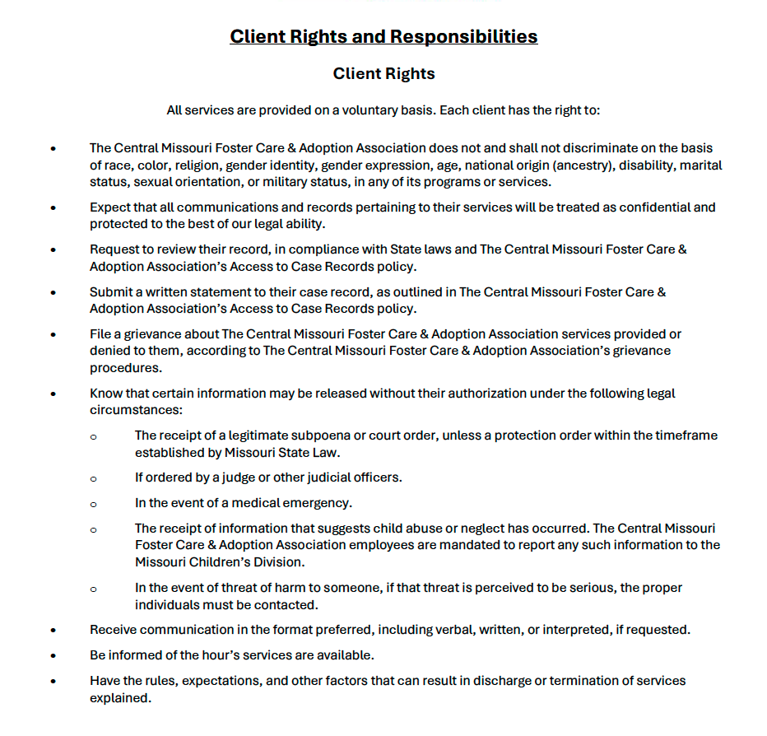

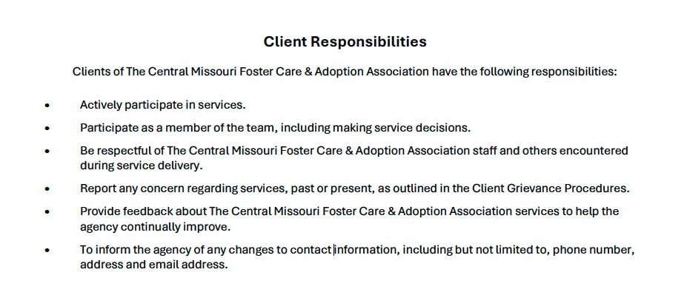

Parent or Guardian

(Print Name) _____________________________ (Signature) ____________________________________

Date: __________________________________

CMFCAA Representative

(Print Name)_____________________________ (Signature) ____________________________________

Date: __________________________________

